**MAP REDUCE PROGRAM TO REPLACE ALL THE COMMAS INSIDE THE DOUBLE QUOTES WITH SPACE:**

**DRIVER CLASS:**

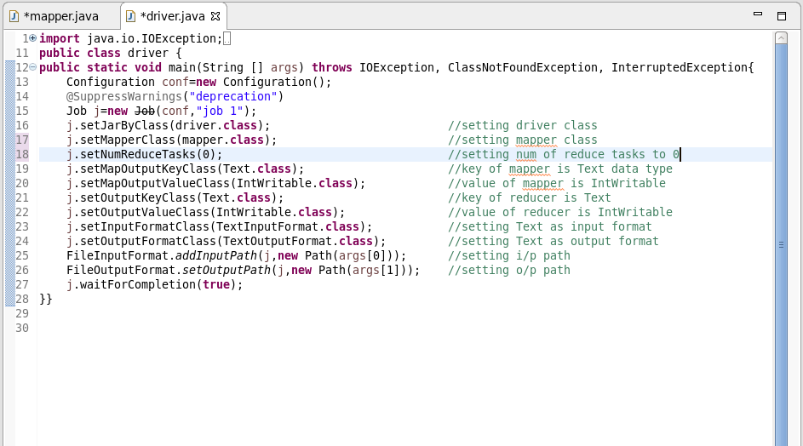

**MAPPER CLASS:**

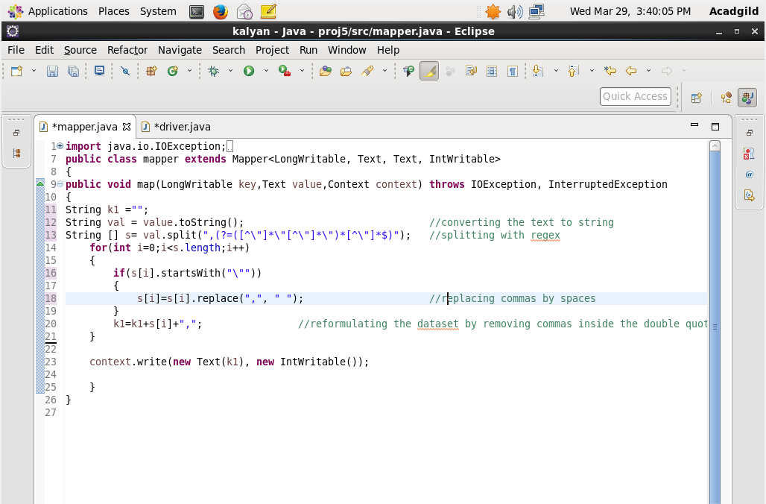

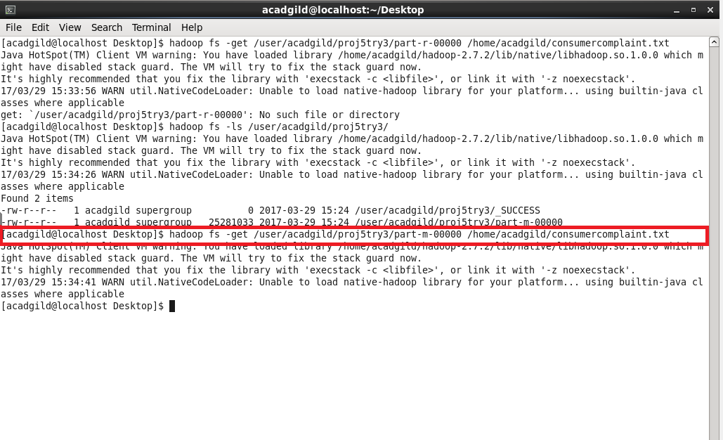

1. *By using hadoop fs –ls /user/acadgild/proj5try/ ,the files inside the proj5try will be listed.*
2. *By using get command, we can copy the file from hdfs to local.*
3. *Part-m-00000 is copied to the local in the name of consumercomplaint.txt with all the commas inside the double quotes replaced with space.*
4. *The processed file is used as the Dataset for executing pig commands.*
5. **WRITE A PIG SCRIPT TO FIND NO OF COMPLAINTS WHICH GOT TIMELY RESPONSE.**

***LOGIC:***

1. *Loading the Dataset into the grunt shell using LOAD command.*
2. *Filtering the Dataset by checking the column 14 is yes.*
3. *Grouping based on column 14 using Group By command.*
4. *Counting the number of complaints using COUNT command.*

*At this stage o/p will be like (Yes, 50832).*

1. *Generating only the count using GENERATE command by eliminating the yes.*

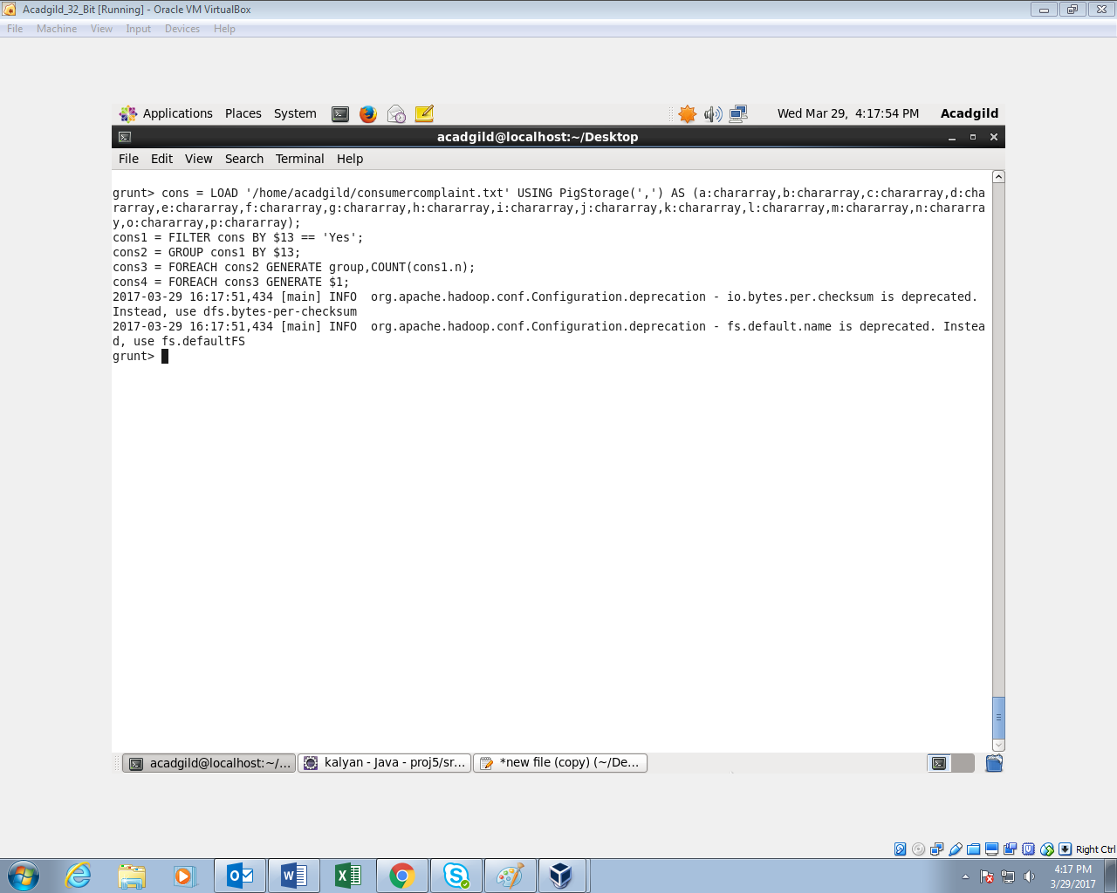

**OUTPUT:**

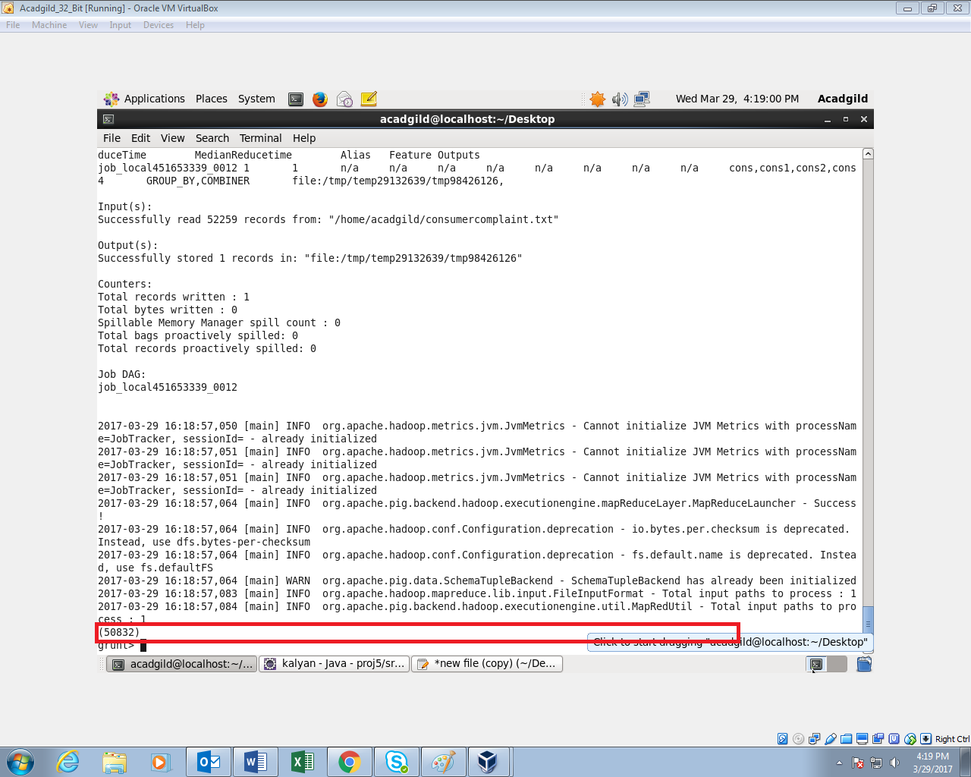

1. **WRITE A PIG SCRIPT TO FIND NO OF COMPLAINTS WHERE CONSUMER FORUM FORWARDED THE COMPLAINT SAME DAY THEY RECEIVED TO RESPECTIVE COMPANY**

**LOGIC:**

1. *Loading the Dataset into the grunt shell using LOAD command.*
2. *Filtering the Dataset by checking whether column 1 and 12 are same.*
3. *Generating only column 1 and 12 using GENERATE command.*
4. *Grouping by all using GROUP ALL command.*
5. *Generating the count using COUNT command*

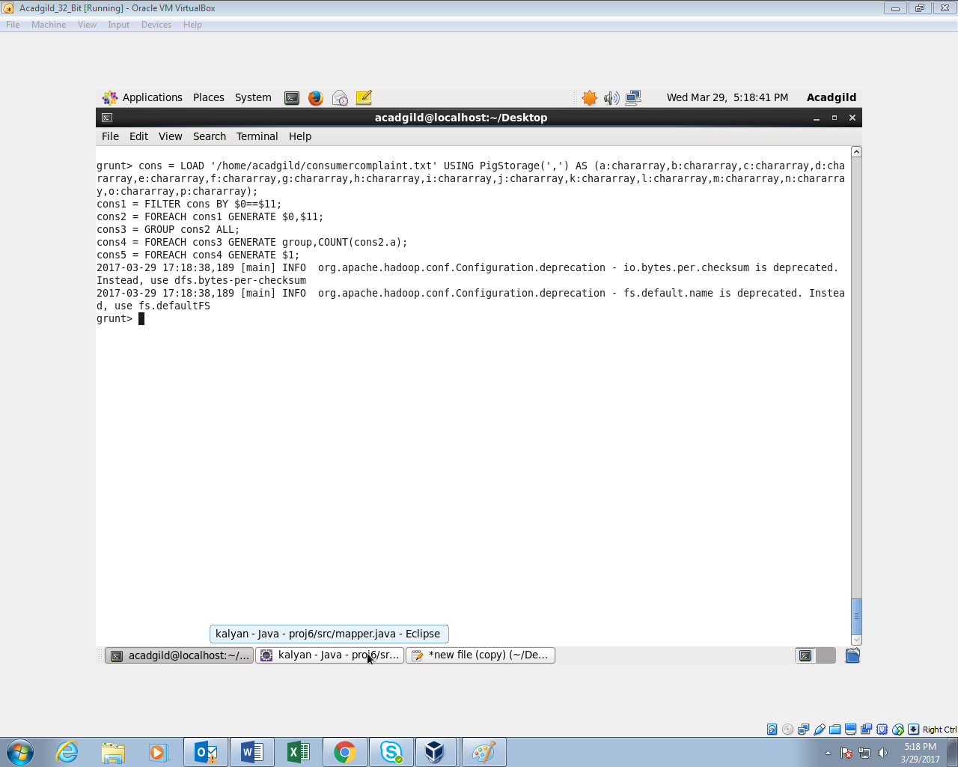

**OUTPUT:**

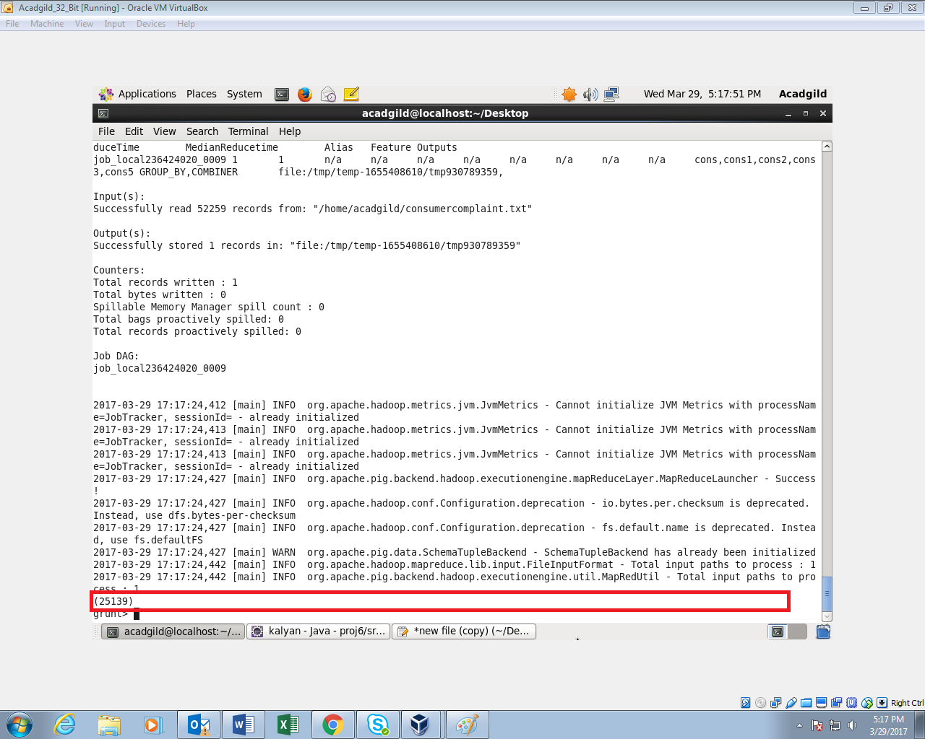

1. **WRITE A PIG SCRIPT TO FIND LIST OF COMPANIES TOPPING IN COMPLAINT CHART (COMPANIES WITH MAXIMUM NUMBER OF COMPLAINTS)**

**LOGIC:**

1. *Loading the Dataset into the grunt shell using LOAD command.*
2. *Grouping the Dataset by Company name column.*
3. *Generating the count using COUNT command.*
4. *Ordering the content based on the count in Descending order using ORDER BY command.*
5. *Displaying only Top 10 companies using LIMIT command (I am displaying only 10 companies)*

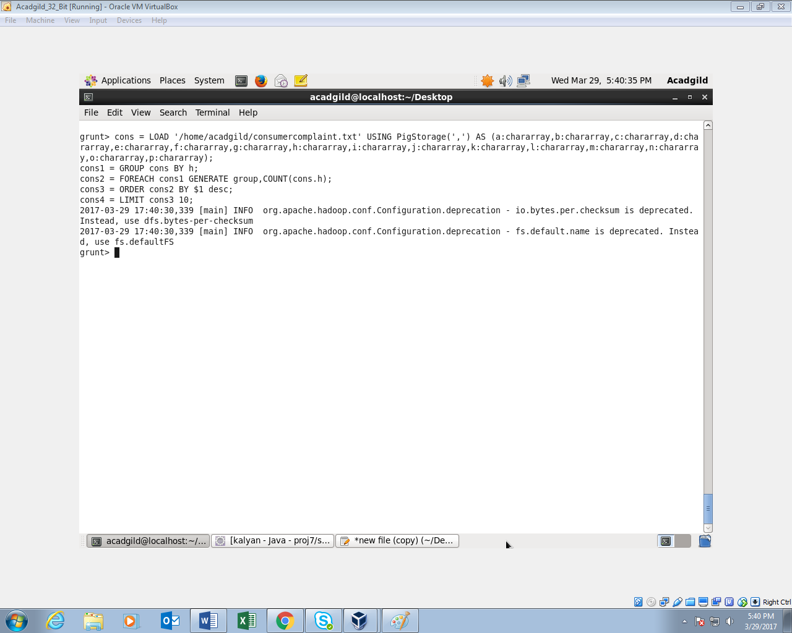

**OUTPUT:**

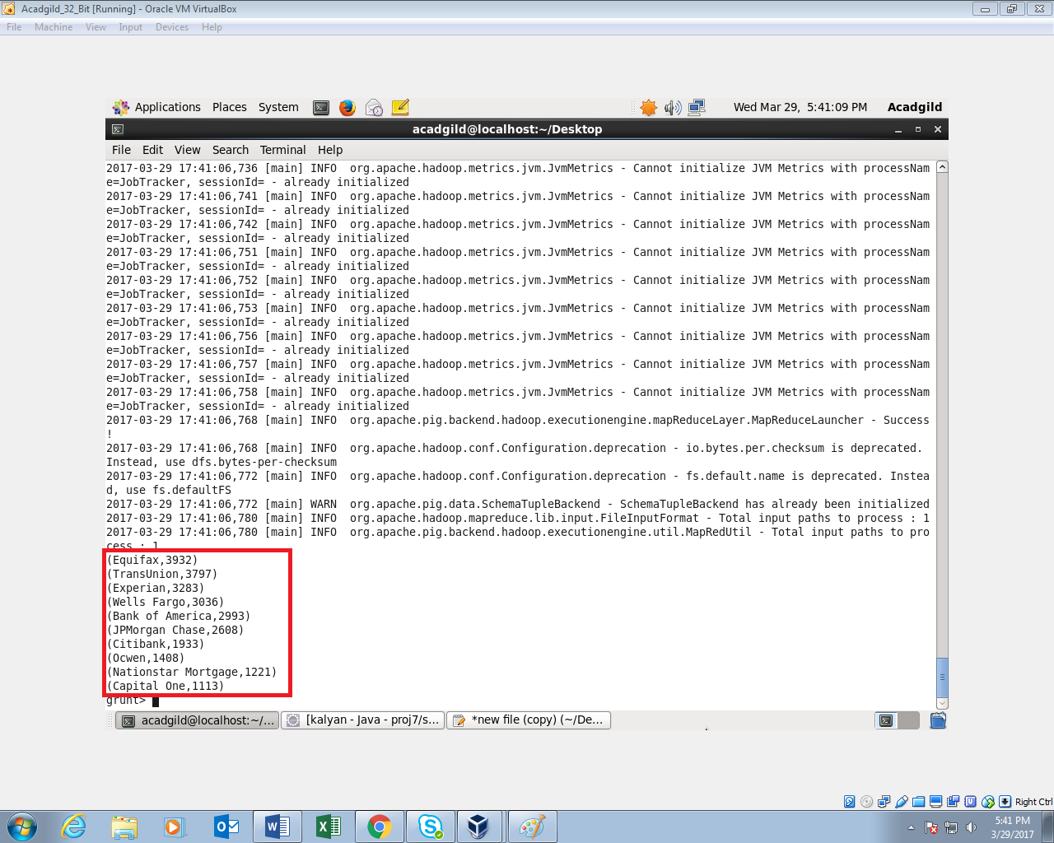

1. **WRITE A PIG SCRIPT TO FIND NO OF COMPLAINTS FILED WITH PRODUCT TYPE HAS "DEBT COLLECTION" FOR THE YEAR 2015**

**LOGIC:**

*1) Filtering the Dataset by checking whether column 2 contains Debt collection using FILTER command.*

*2) Generating the year (yyyy) from the column*

*3) Generating only the Year using GENERATE and SUBSTRING command*

*4) Filtering the contents by year =”2015”;*

*5) Grouping by Debt collection using GROUP BY command.*

*6) Generating the count using COUNT command.*

*7) Displaying only the count as output.*

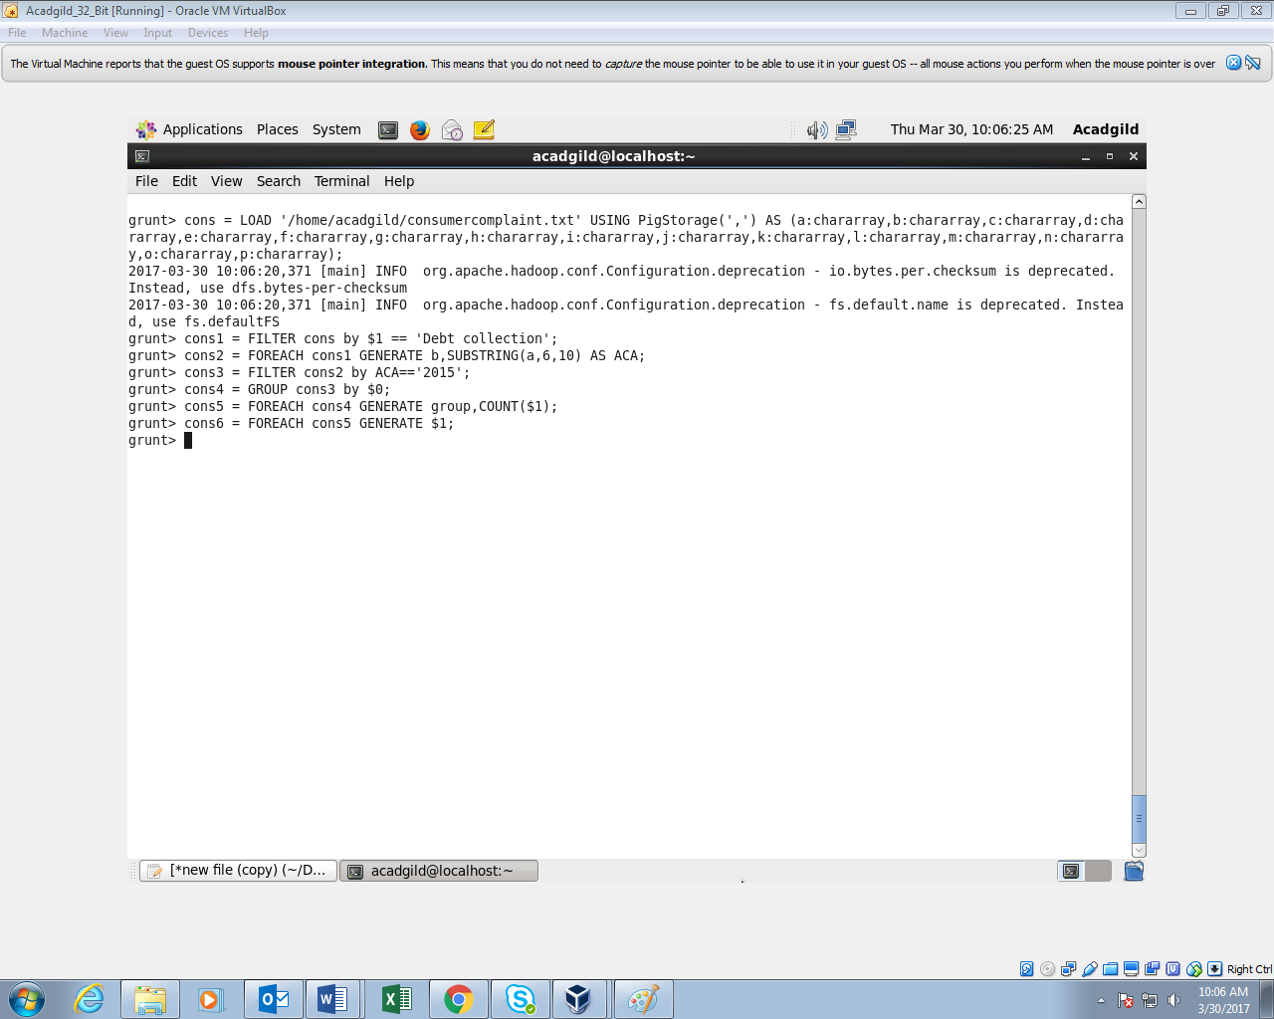

**OUTPUT:**

